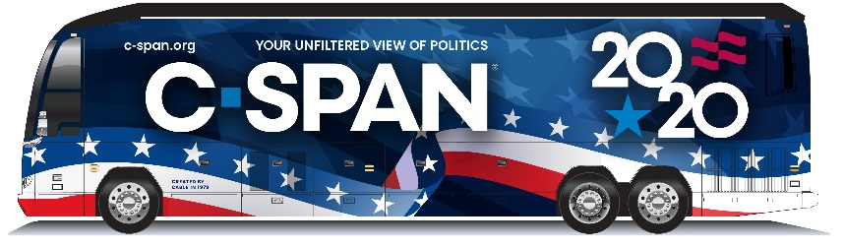

Dear ______,

The C-SPAN Bus (Campaign 2020 tour) is coming to (CITY), and we hope you can come out to take a look!

The Bus, C-SPAN's mobile classroom and production studio, will be at (LOCATION)on (DAY, DATE), from (TIME) to (TIME). The Bus team will be on hand to talk to students and visitors about the Bus and C-SPAN's in-depth coverage of the political process(, notably its comprehensive coverage of Campaign 2020).

We hope you can join us at (LOCATION) to interact with students, share your experience in public service and tour the Bus! Please let us know if you or your colleagues are able to attend.

We also encourage you to share your visit on social media. You can follow the Bus on Twitter and Instagram, and you can read more about it here.

Best,
____

